**Use Case 2: Facial Detection Comparision for face_recognition and Amazon Rekognition**

This report presents a comparative analysis of two facial biometric systems: the open-source face_recognition library and the Amazon Rekognition API service. The comparison is based on the performance of each system when applied to the task of detecting and recognizing faces on three images.

**Performance Comparison**

Upon application to three test images, both systems were capable of detecting most faces. However, Amazon Rekognition outperformed the face_recognition library, demonstrating both a higher face detection rate and significantly higher similarity scores, as evidenced by the provided histograms.

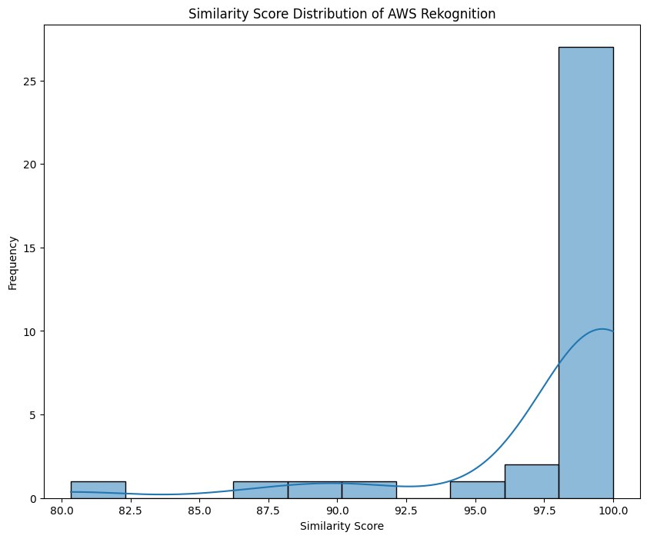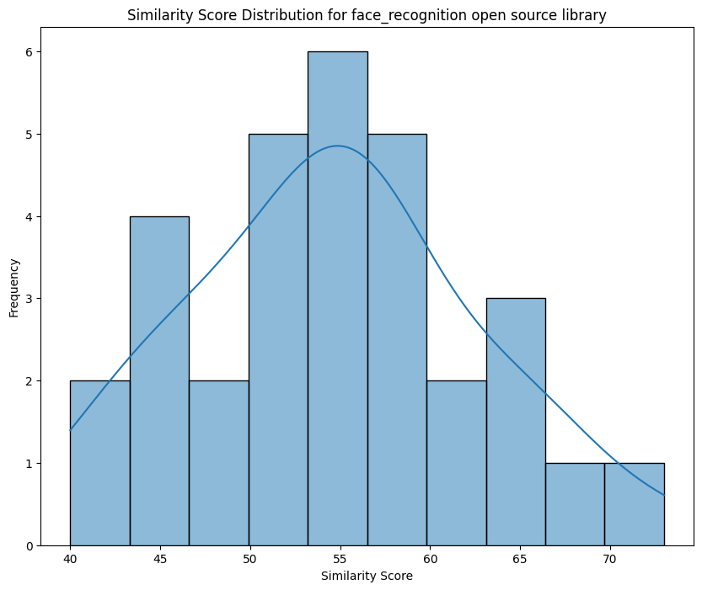

**Pros and Cons for each system**

|  |  |  |
| --- | --- | --- |
|  | **face_recognition** | **Amazon Rekognition** |
| Pros | * Greater control over data privacy * Cost-Effectiveness: reduce the cost of using an external service. | * High accuracy with and extremely high similarity score * Cloud-Based Infrastructure: high scalability and ease of integration with existing AWS services. * Continual Updates: Benefits from Amazon's investment in AI, providing ongoing enhancements to the service. |
| Cons | * Lower accuracy in both face detection and similarity scoring * Unable to detect several faces * Technical Demands: Deployment and maintenance may require in-house expertise or external consultancy. | * Operational Costs: could be substantial at scale. * Data privacy concerns due to cloud-based processing |

**Assessment**

Based on this pros and cons of both services Amazon Rekognition appears to be able to significantly benefit our employee verification process through its higher accuracy and reliability, ensuring that the attendance system is both accurate and comprehensive. The scalability of Amazon's service could also accommodate our company's future growth. However, the decision should be balanced against cost considerations and privacy concerns. The chosen system must align with the company's operational requirements and values.

**Labeled Images**

*face_recognition*

Picture 1:

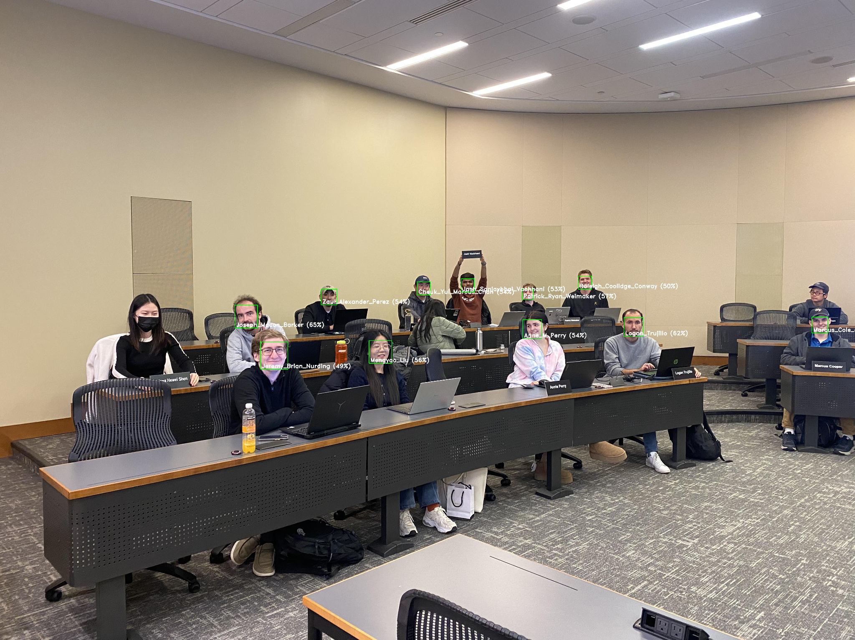

The open source library failed to detect two people in our test images. The first omission (Hewei Shen) can likely be attributed to her wearing a face mask, a known complicating factor for facial detection algorithms. The second undetected person (Tianyi Chen) presents a different challenge. While he was not wearing a hat and glasses in the reference image used for encoding, he was wearing both in the test image. This discrepancy in appearance could have hindered the algorithm's ability to accurately face_recognition

Picture 2:

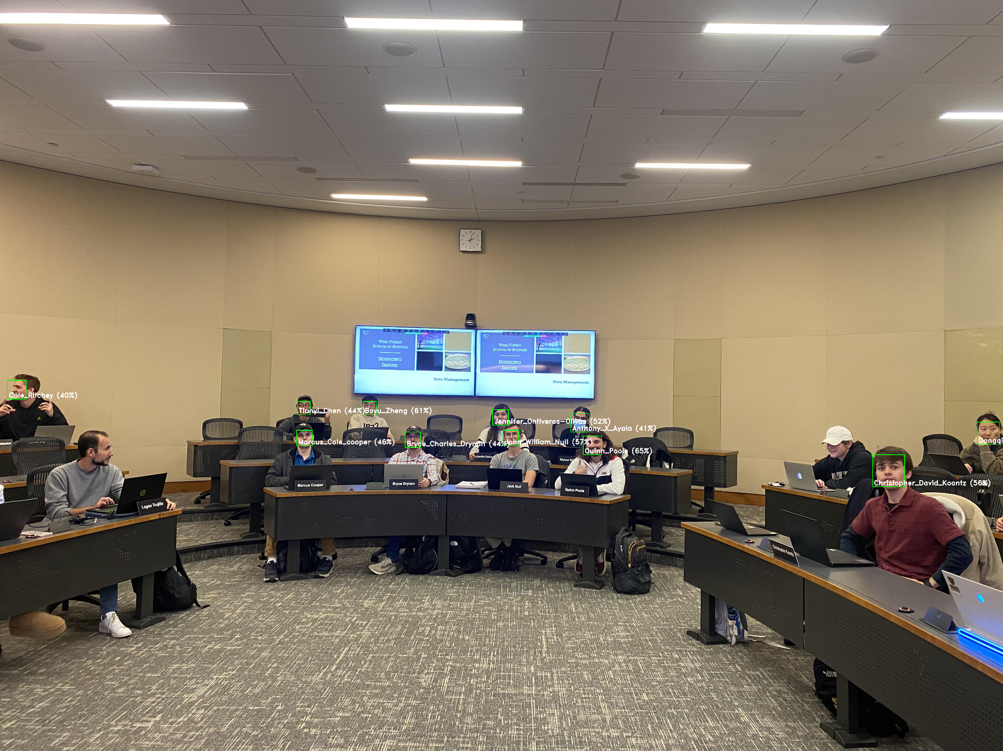

Two faces went undetected and one was incorrectly identified. The model was unable to recognize Logan, who was not facing the camera directly. Allan posed a similar challenge, with his hat obscuring a significant portion of his facial features. The third case involved Skylour, who was wearing a mask. This combined with a hairstyle resembling 'Anthony', seems to have led the algorithm to misidentify Skylour as Anthony.

Picture 3:

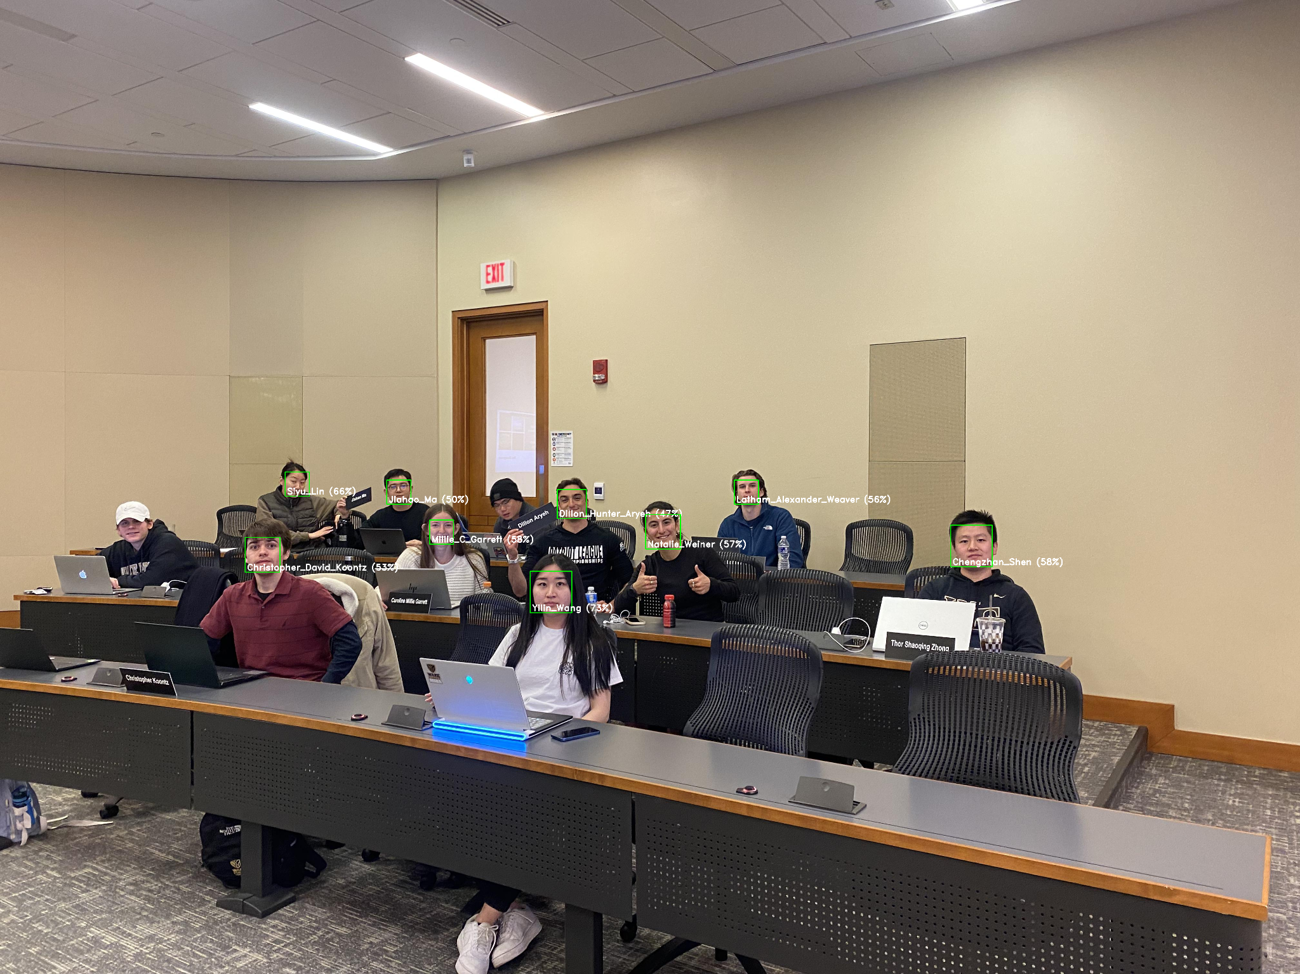

This labeled image present instances of non-detection and misidentification. Allan and Songlin were not recognized, potentially due to people wearing hats which may interfere with the algorithm's ability to detect some features. Additionally, Thor was incorrectly identified due to the absence of his reference image in our database, coupled with a hairstyle that closely resembles that of Chengzhan Shen. This similarity appears to have led the algorithm to incorrectly match 'Thor' with Chengzhan's name.

*Amazon Rekognition*

Picture 1:

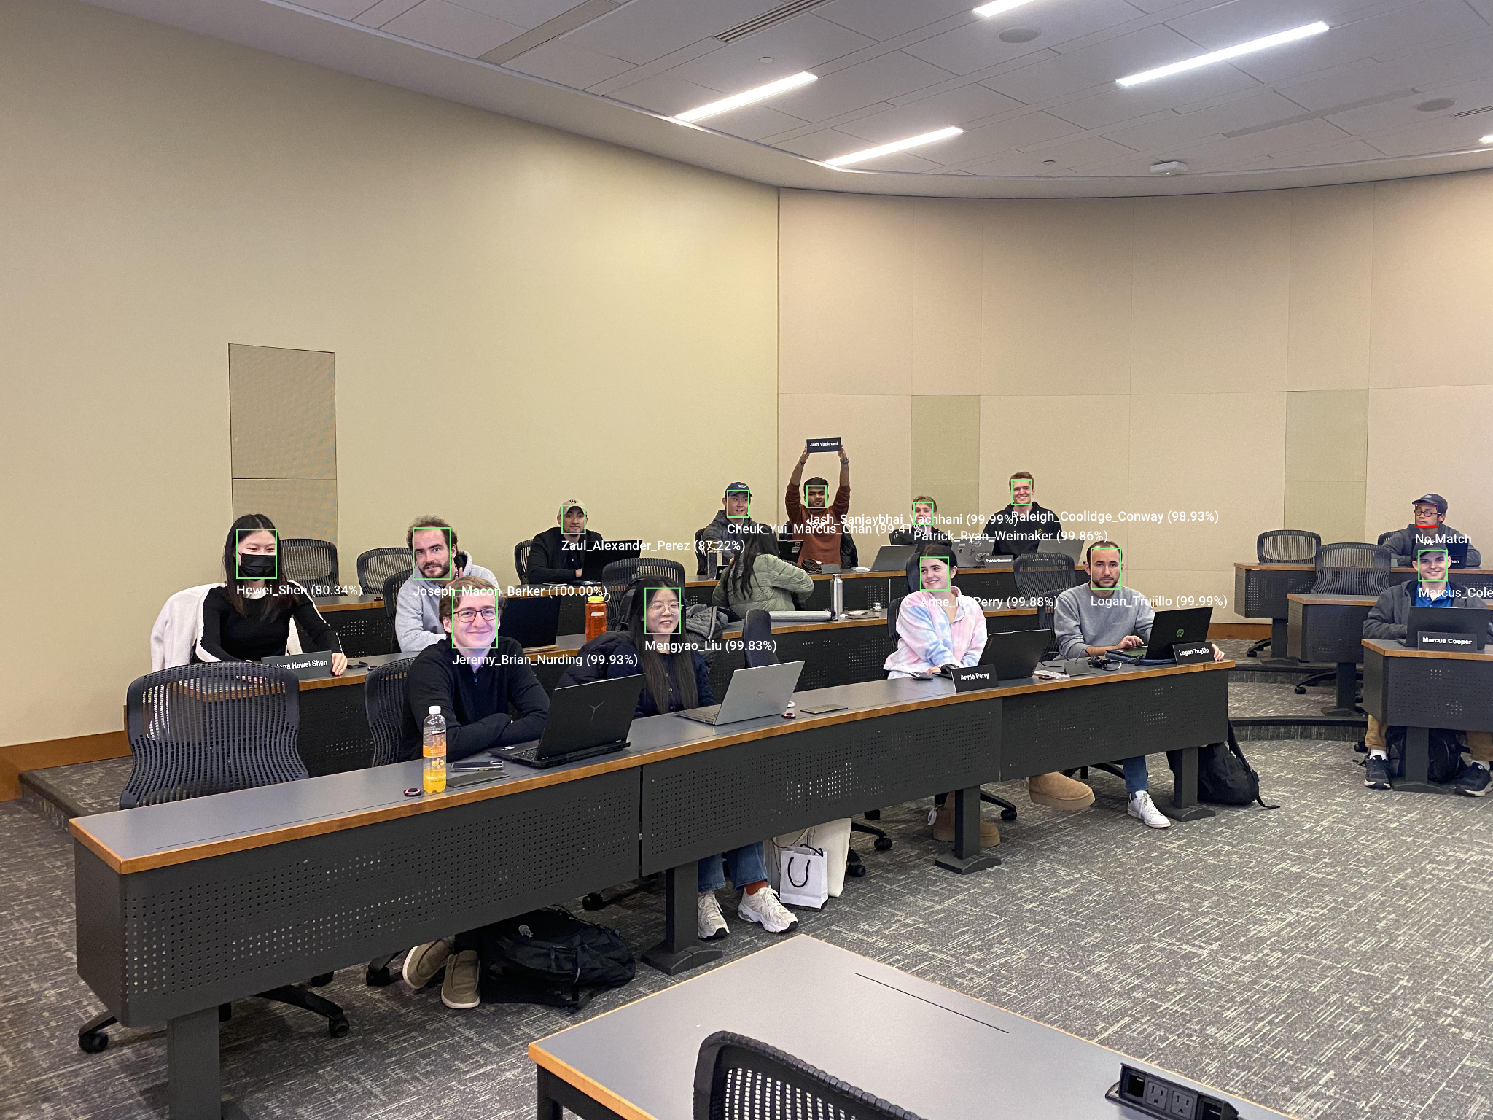

Amazon Rekognition impressively identified Hewei even with a mask on. However, it struggled to recognize Tianyi Chen who appeared with glasses and a hat, unlike his reference image. This suggests that the system's ability to handle appearance changes due to accessories could be improved.

Picture 2:



Amazon Rekognition performed accurately, matching all faces except for Allan, whose face was significantly obscured by a hat. This demonstrated a huge advantage over the open-source library, especially in its ability to detect Logan and Skylour with high similarity scores, showcasing its robustness in face recognition even with partial obstructions.